Project: Staycatin.com Listing

Problem Statement: -

The data presented to you is from an online platform StayCatin.com that lets you book properties for a particular date per your requirement (like Airbnb). You have joined the firm as a business analyst and have been asked to help the business management make smart decisions. They have provided you with the data, which lists down details of each property listed on their website, the reviews and how the price fluctuated with time. You need to come up with a dashboard that helps management answer the key questions:

1. Top 10 earners

2. Relationship between price and earnings

3. Any location (shore) getting more earnings

4. Relationship between price and reviews Create a storyboard with the insights also.

Dataset Link: <https://docs.google.com/spreadsheets/d/1DJjooTNVL6lXqiiCowOqi6Js4rUBb2GSAyGHcdX1aY8/edit#gid=1154935988>

Importing Dataset

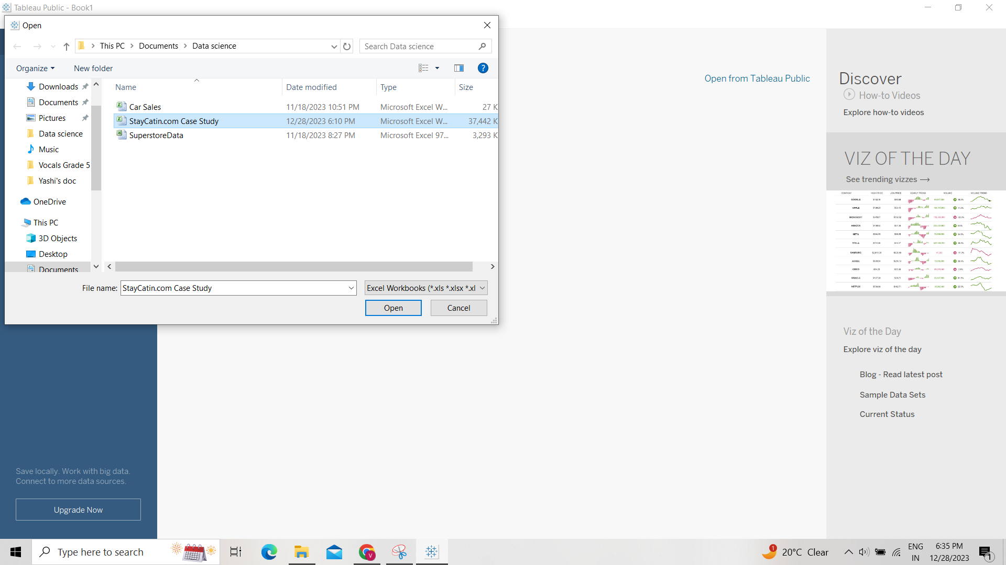  
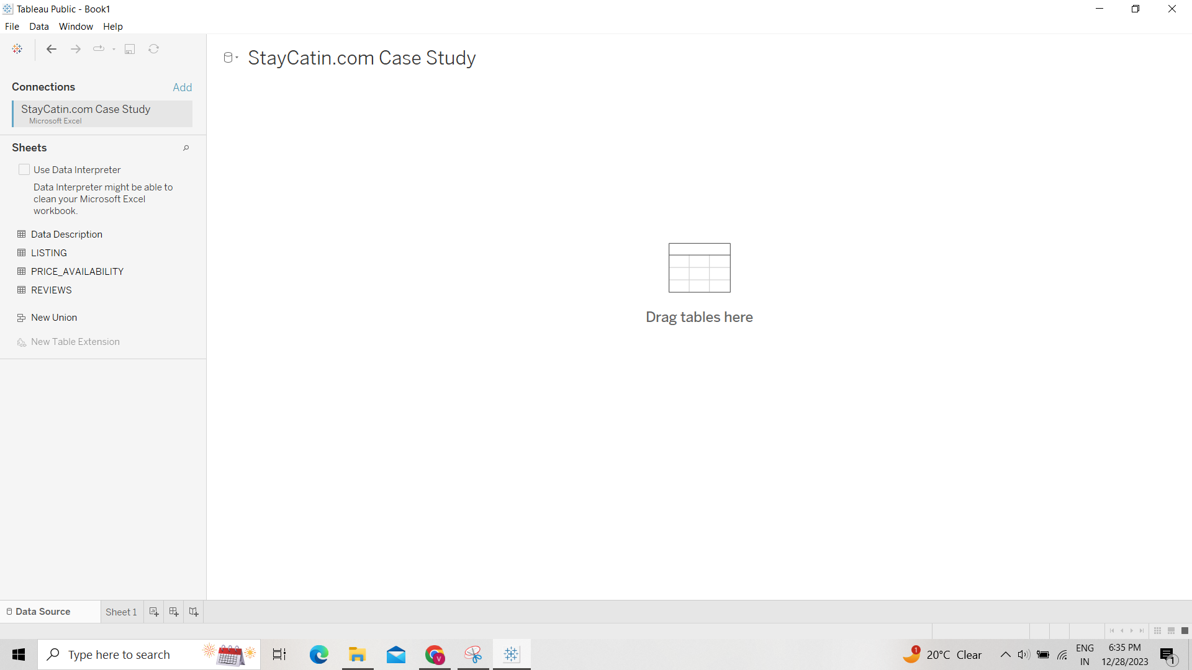

It has 4 tables:

1. Data description: to describe each column header in all tables, just has description for those.
2. Listing -> will be majorly used, has many columns to provide property details such as name, id, host, host id, location, price, reviews out of 10 etc.
3. Reviews -> has reviewer name, comments, date of comment and id
4. Price Availability -> has listing id, date, available or not, daily Price.

Drag Listing table for now   
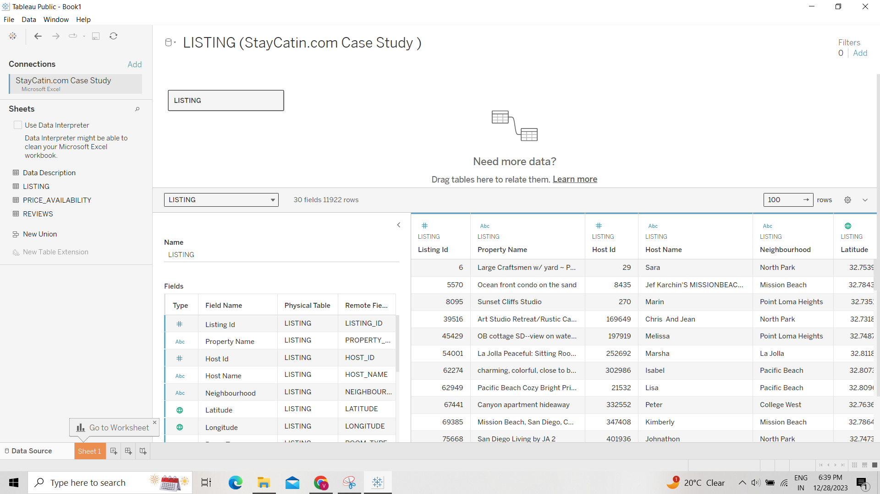

#### Question: Which Room Type has the Maximum Number of Listing?

Tableau has created a measure called Listing(count) which works as calculated field Count([listing]), providing the count of listing. We can use this to find the answer.

Row: Room type, Text: Listing (count)   
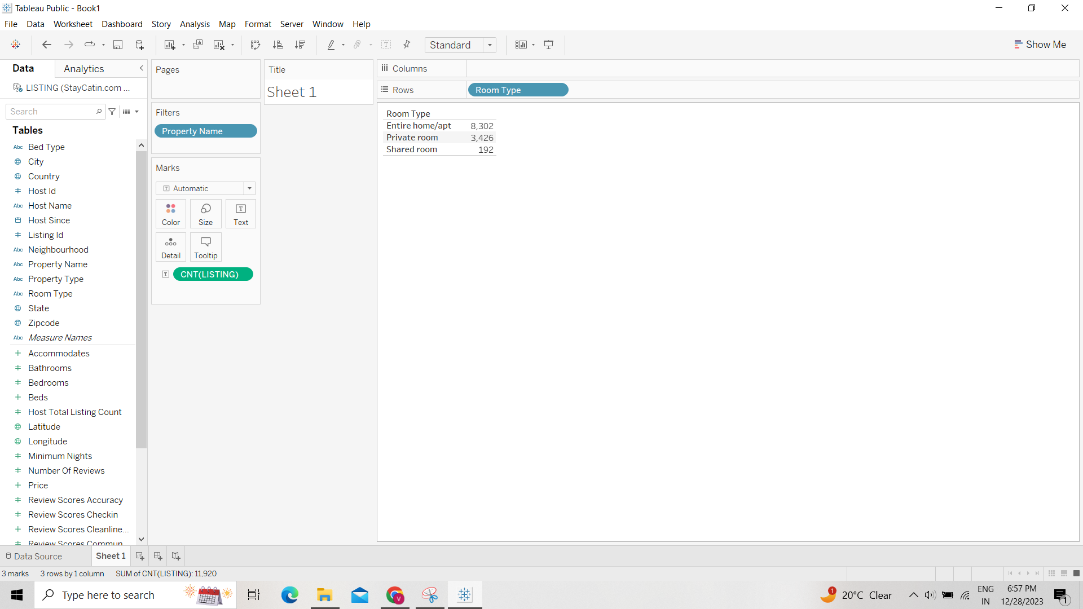

Answer is Entire Home / Apt

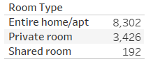

#### Question: Suppose you want to create a new field which will represent the Total Earnings, then which of the following fields you will use?

Ans: Price and Number of Reviews (since number of bookings is not there)

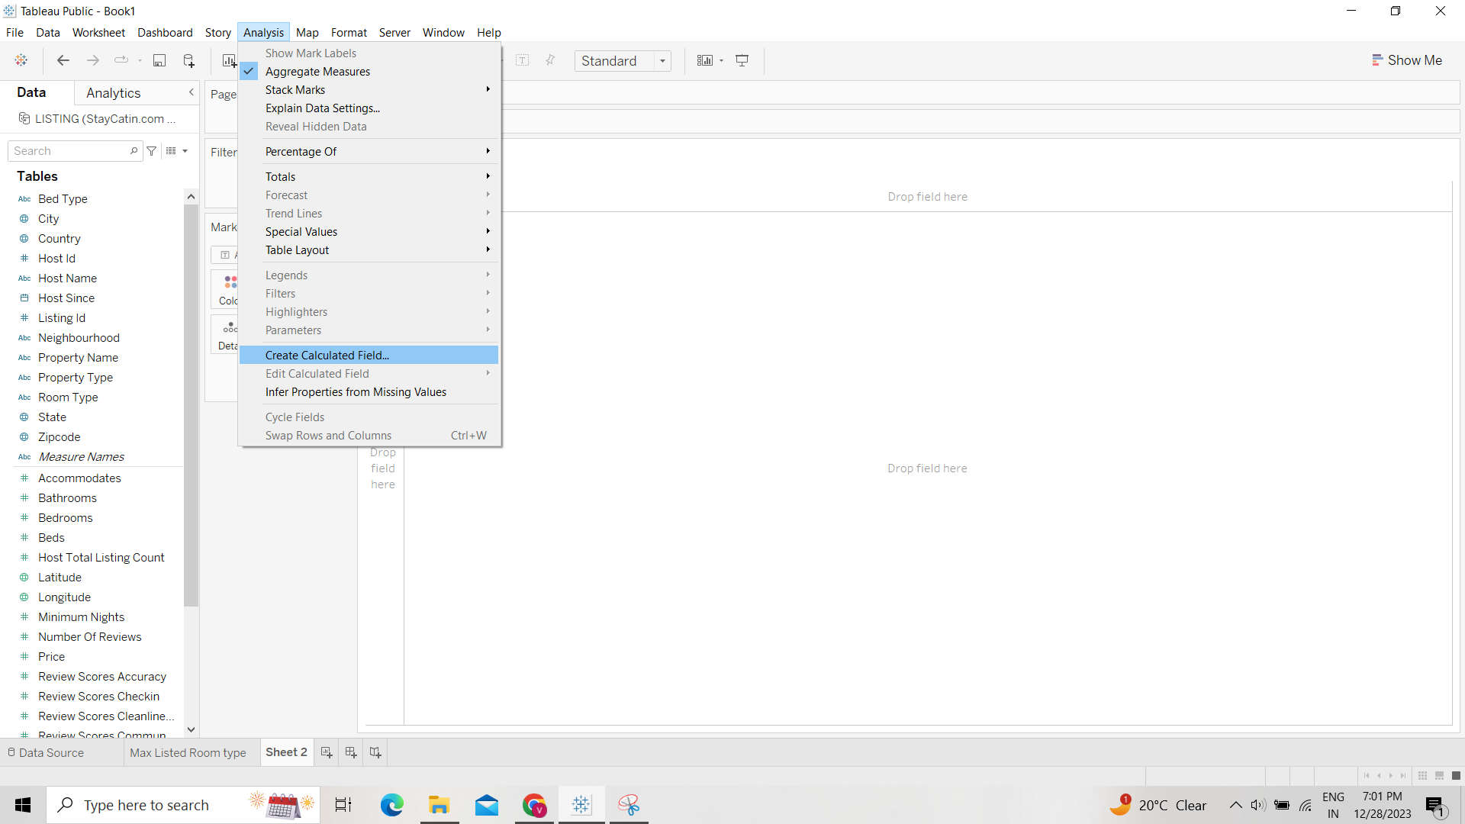

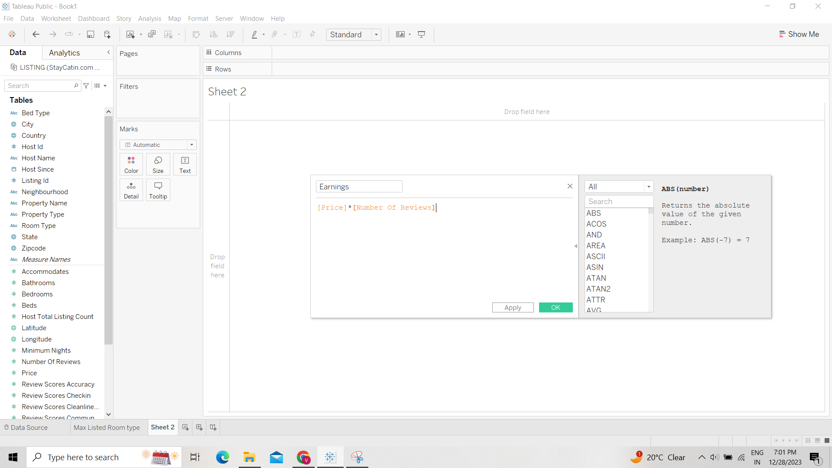

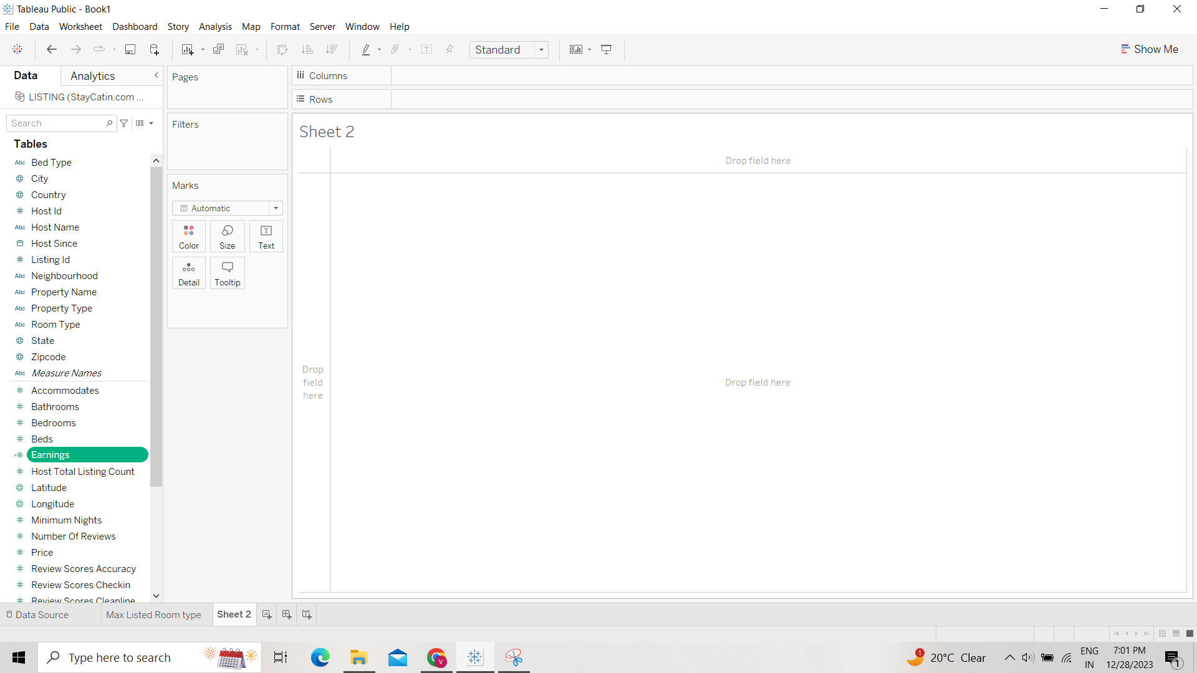

#### Question: With the help of the Bar Chart find out the Top 3 Host names in terms of Total Earnings?

Row: Host Name, Column: Earnings (created calculated Field earlier) and then sort in descending order.

Ans: Michale, 710 Beach Rentals and John

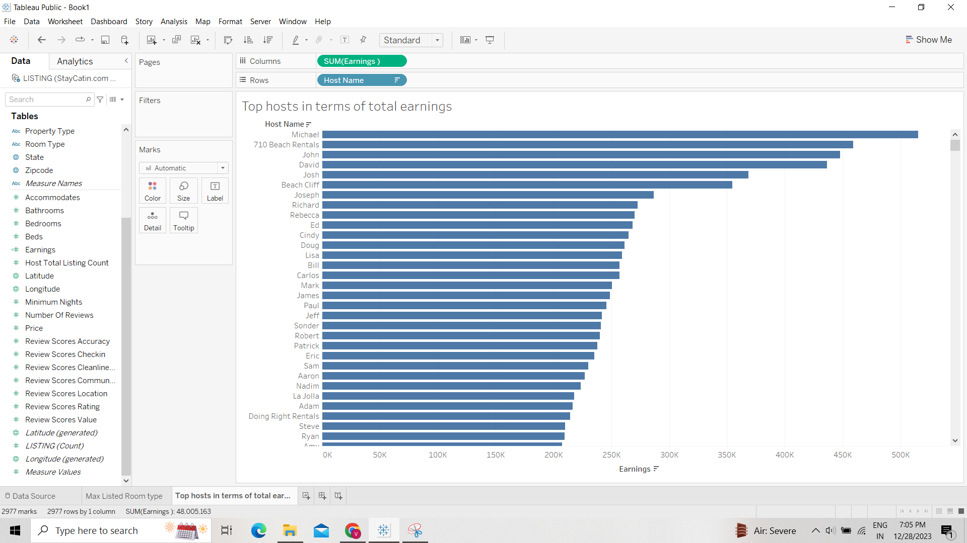

#### Question: Study the relationship between Price and Earnings for different Host Ids and find out the correct observations

Dimension to consider: Host ID, Measures to consider: Price and Earnings   
Scatter plot can be used to display data of two variables (measures)

Col: Price and Row: Earnings

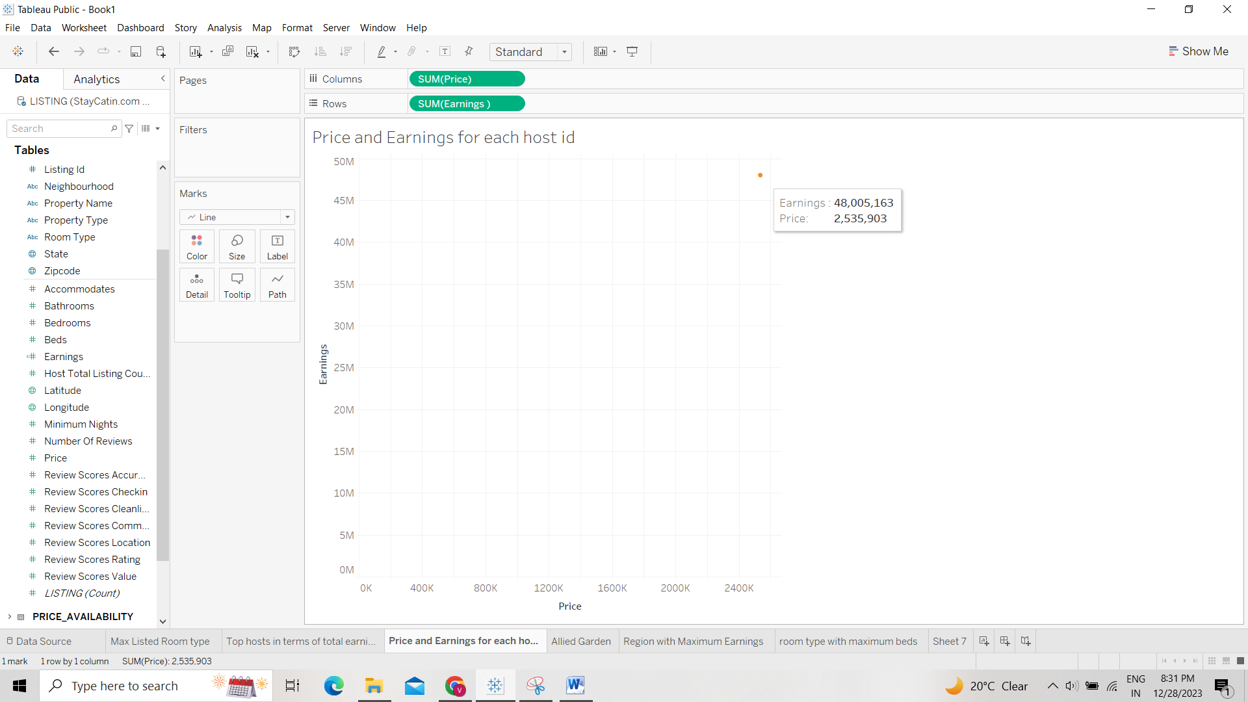

For individual host names put it in details

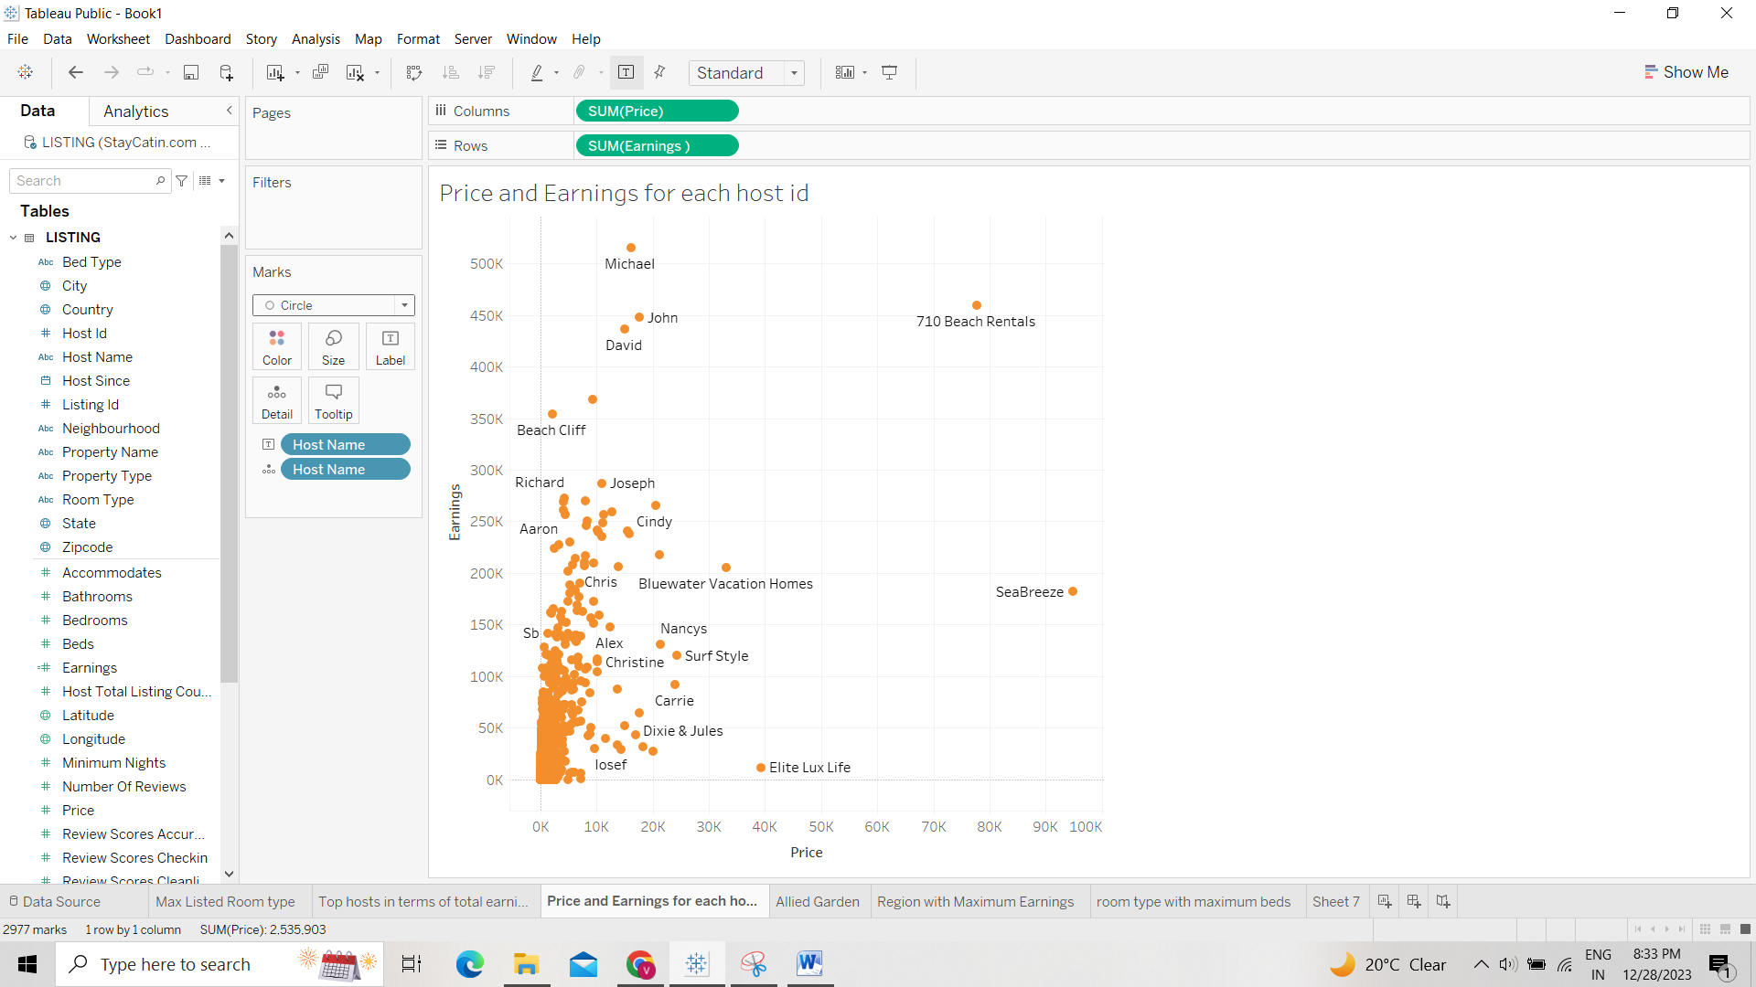

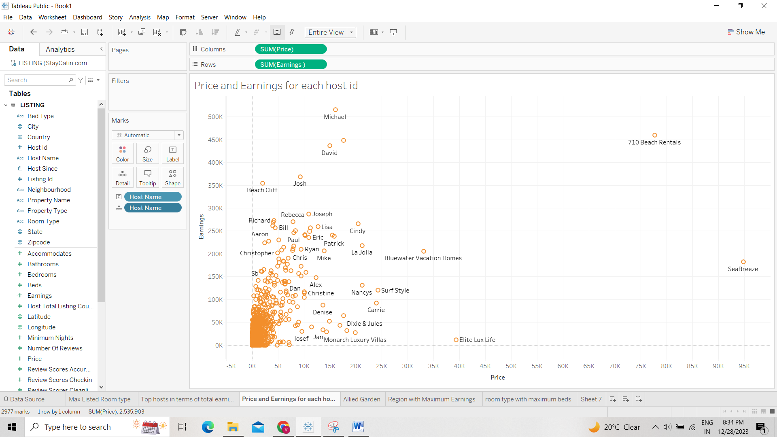

As such no specific relation between price and earning but following can be observed

1. Host name Sea Breeze (price is in x axis) has the maximum Price
2. Host name Michael has most earnings
3. Sea Breeze and Michael can be considered as outliers in price v/s earning graph
4. Cindy, Surf style and Carrie has price more than 20k

#### Question: Find the Count of Listing in “Allied Gardens” under the property type “Townhouse”.

By creating Heat map of col: Neighbourhood and row: property type, text: host total listing (square)

Ans: 0 for townhouse Allied Gardens

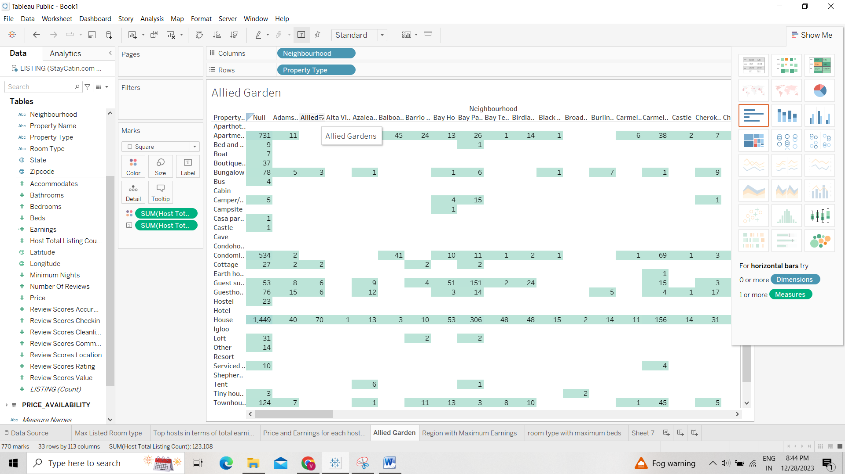

#### Question: Find the region which has the Maximum Total Earnings?

Ans: San Diego

Col: Latitude, Row: Longitude, Detail: Country, State and City, Shape: Earnings

Will reflect San Diego as biggest dot

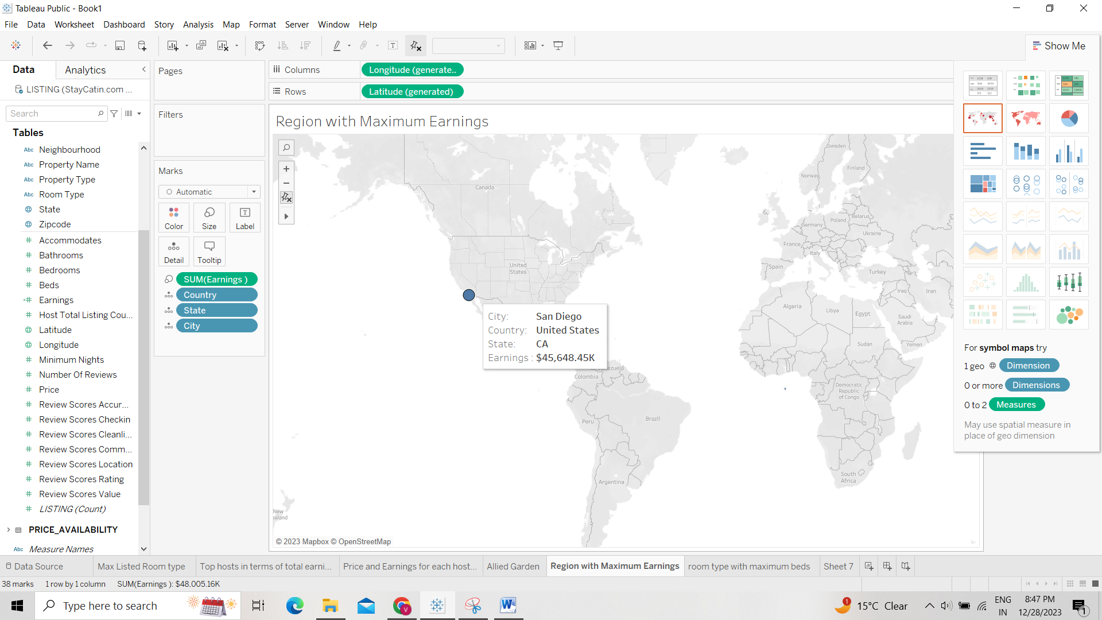

#### Question: Using a Pie Chart find out which room type has the maximum number of beds?

Ans: Entire Home/Apt

Colour: Room type, Angle: Beds, Labels: Room type and beds

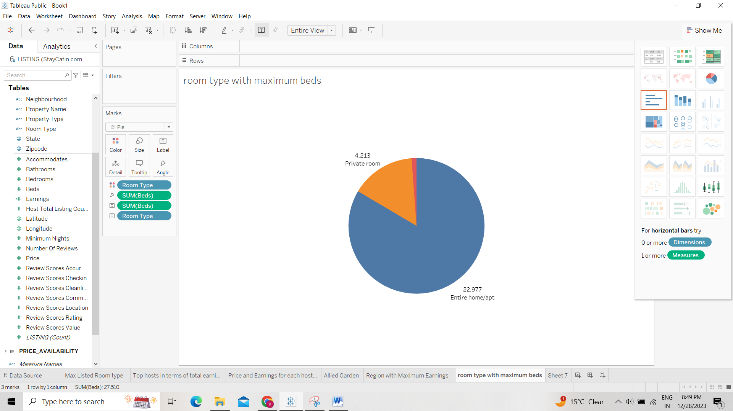

#### Question: We also have price and availability data, So create a line chart to know how the avg price has fluctuated over time for the available properties

See how the price has fluctuated over time, and find out how many times the average daily price was above 400?

Answer: 1

By creating Line chart

First join the price availability table

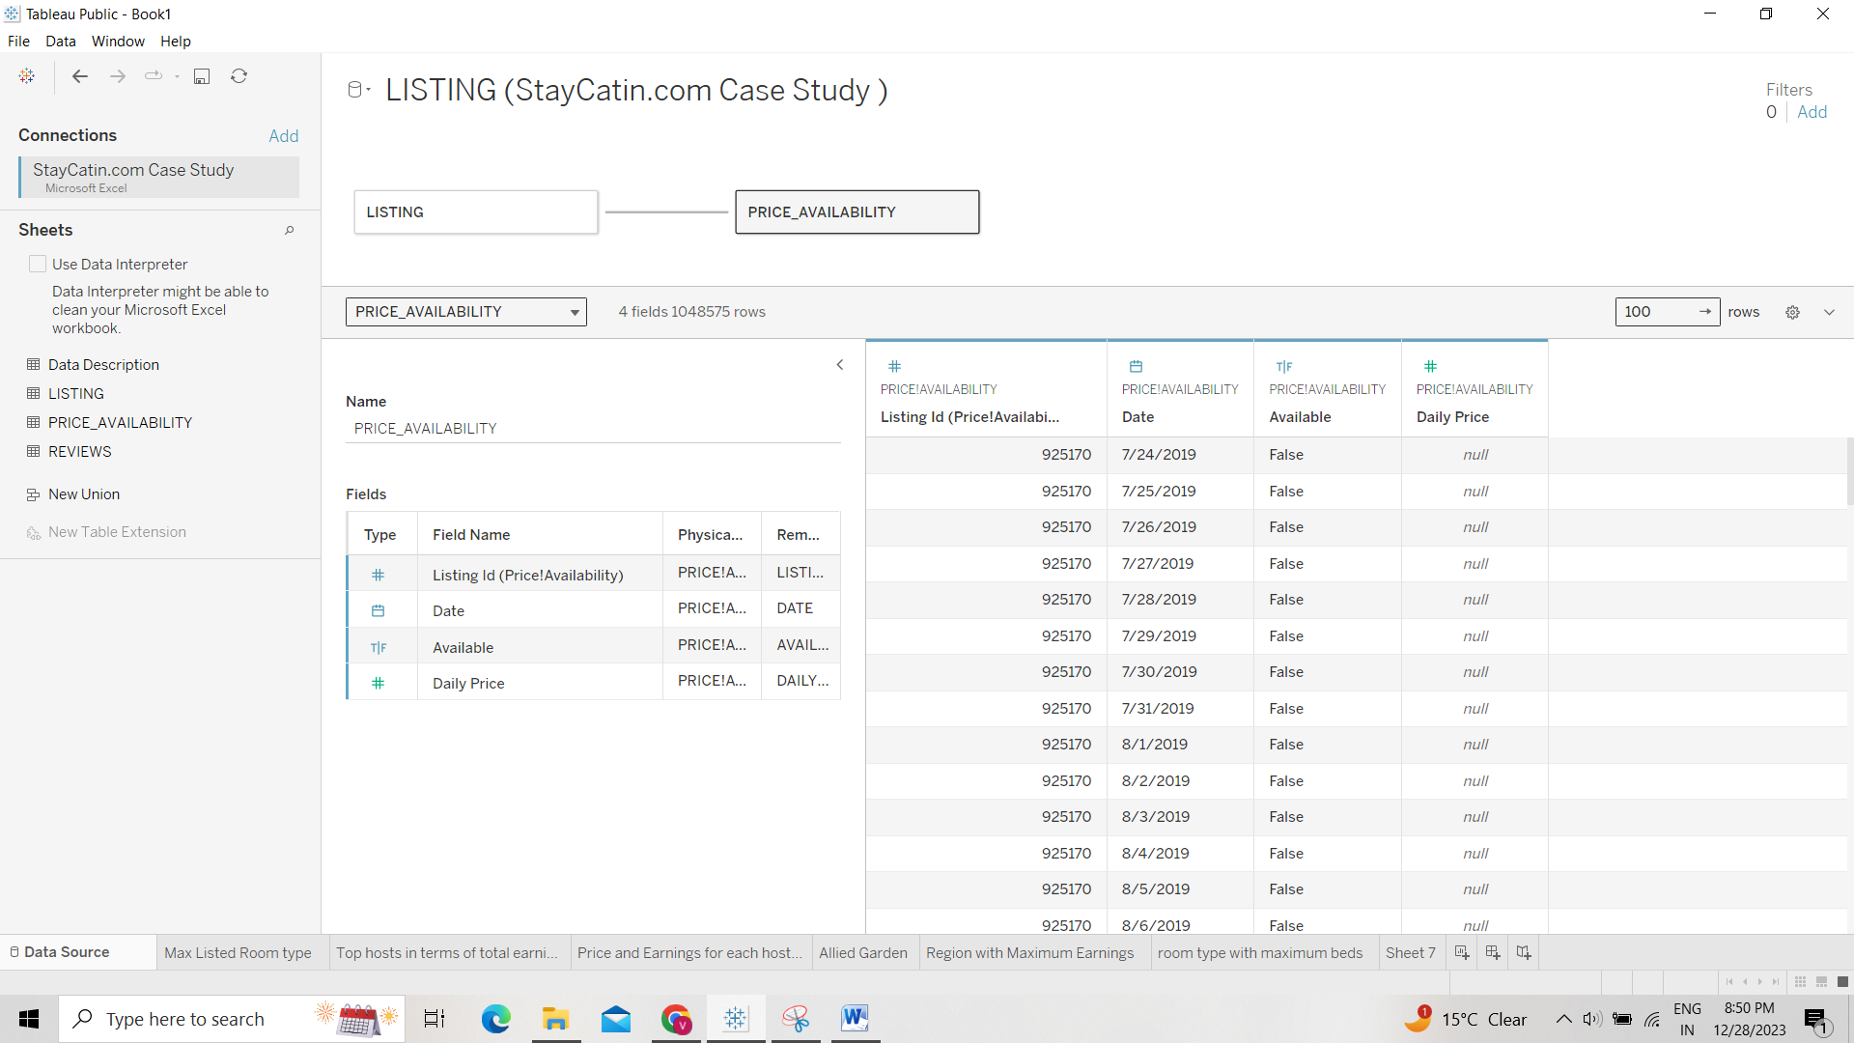

Then Col: Day of date (breakdown from year to date), Row: Daily Price (but make it AVG not SUM)

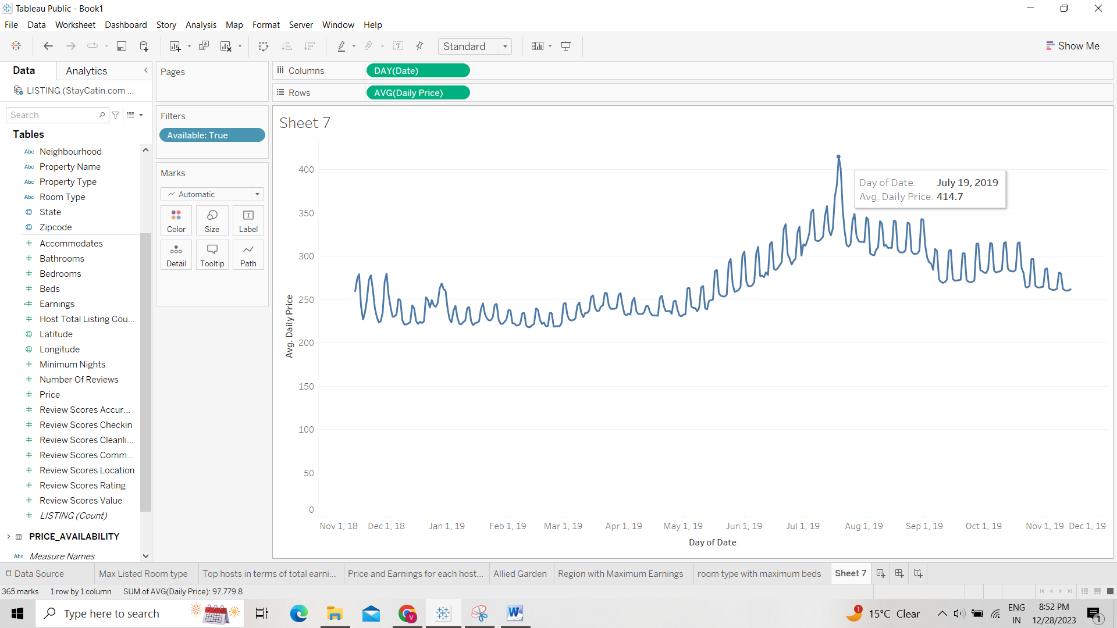

1. TOP 10 Earners :  
   Use top Hosts in terms of Earnings  
   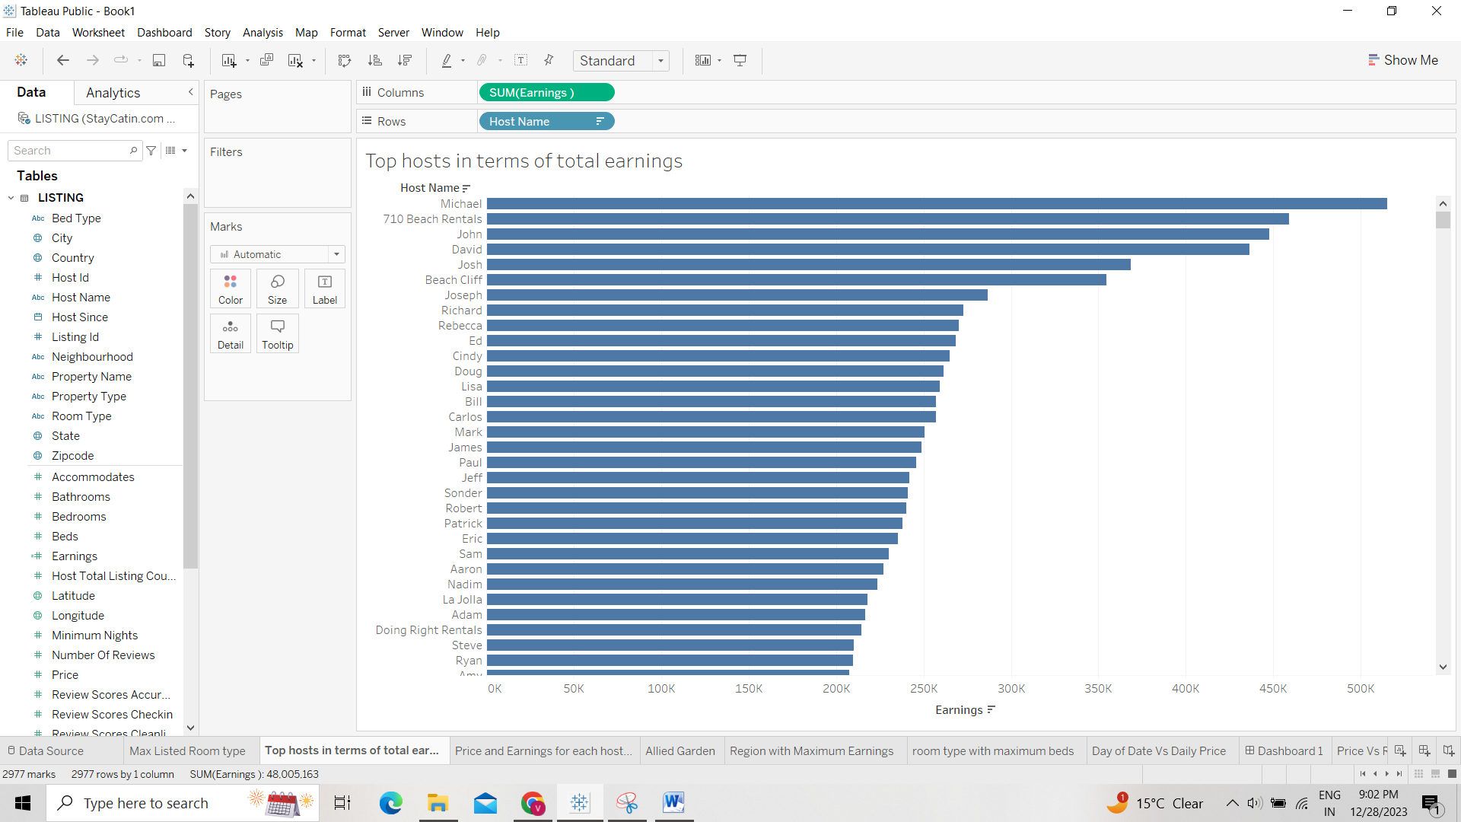
2. Relationship between price and earnings: Use Price and Earnings for each host graph   
   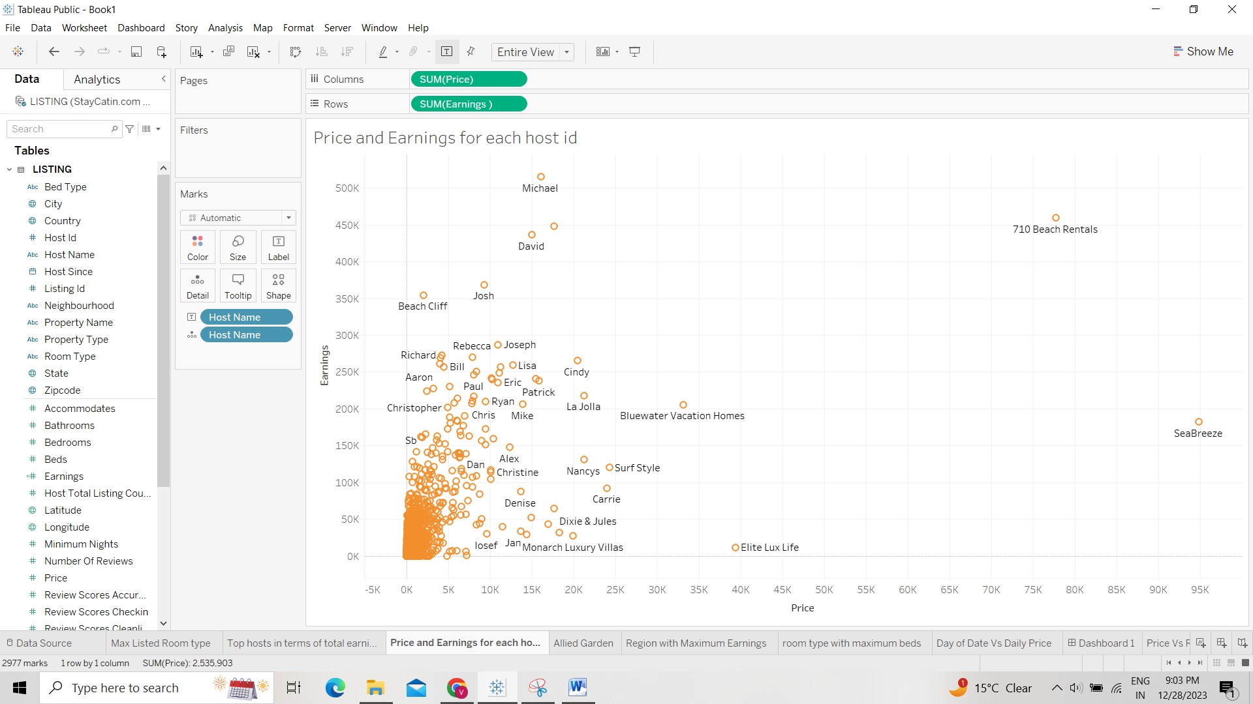
3. Any location (shore) getting more earnings: Use Map   
   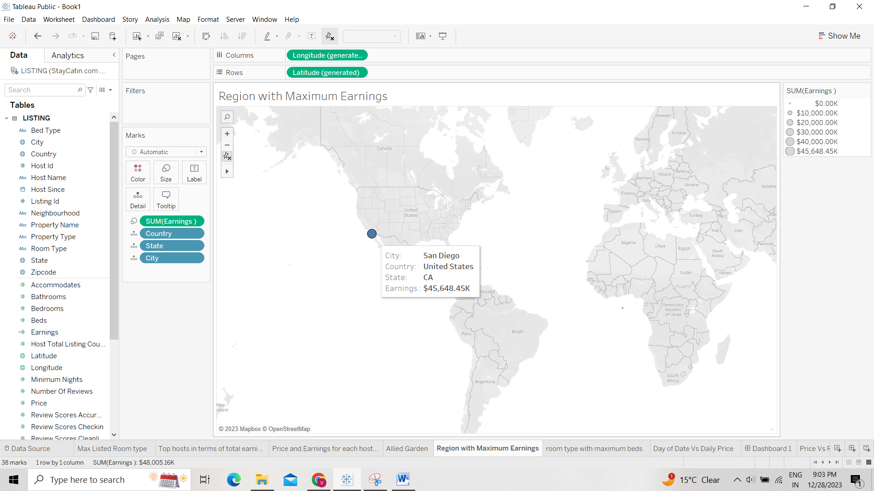
4. Relationship between price and reviews   
   Column: Price, Row: Number of reviews, Details: Listing ID   
   Ans: Inversely Proportional (More the price, lesser the reviews)  
   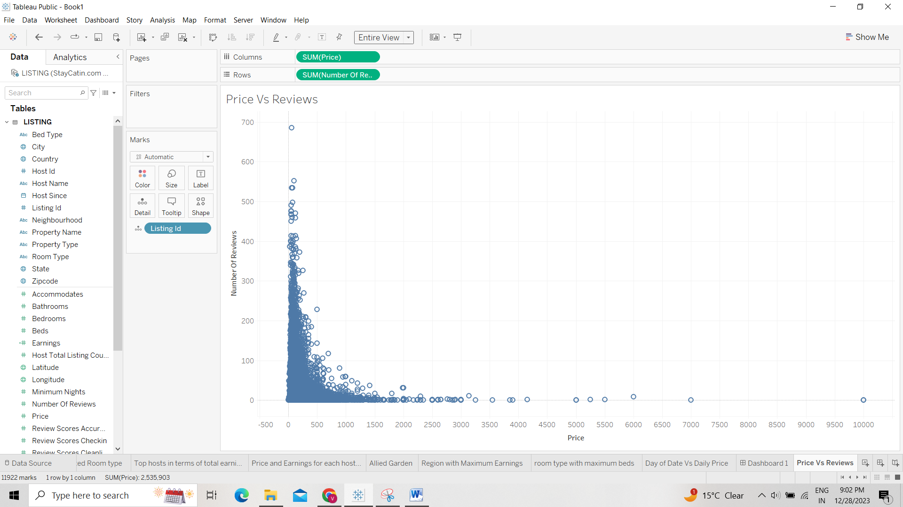

Dashboard:

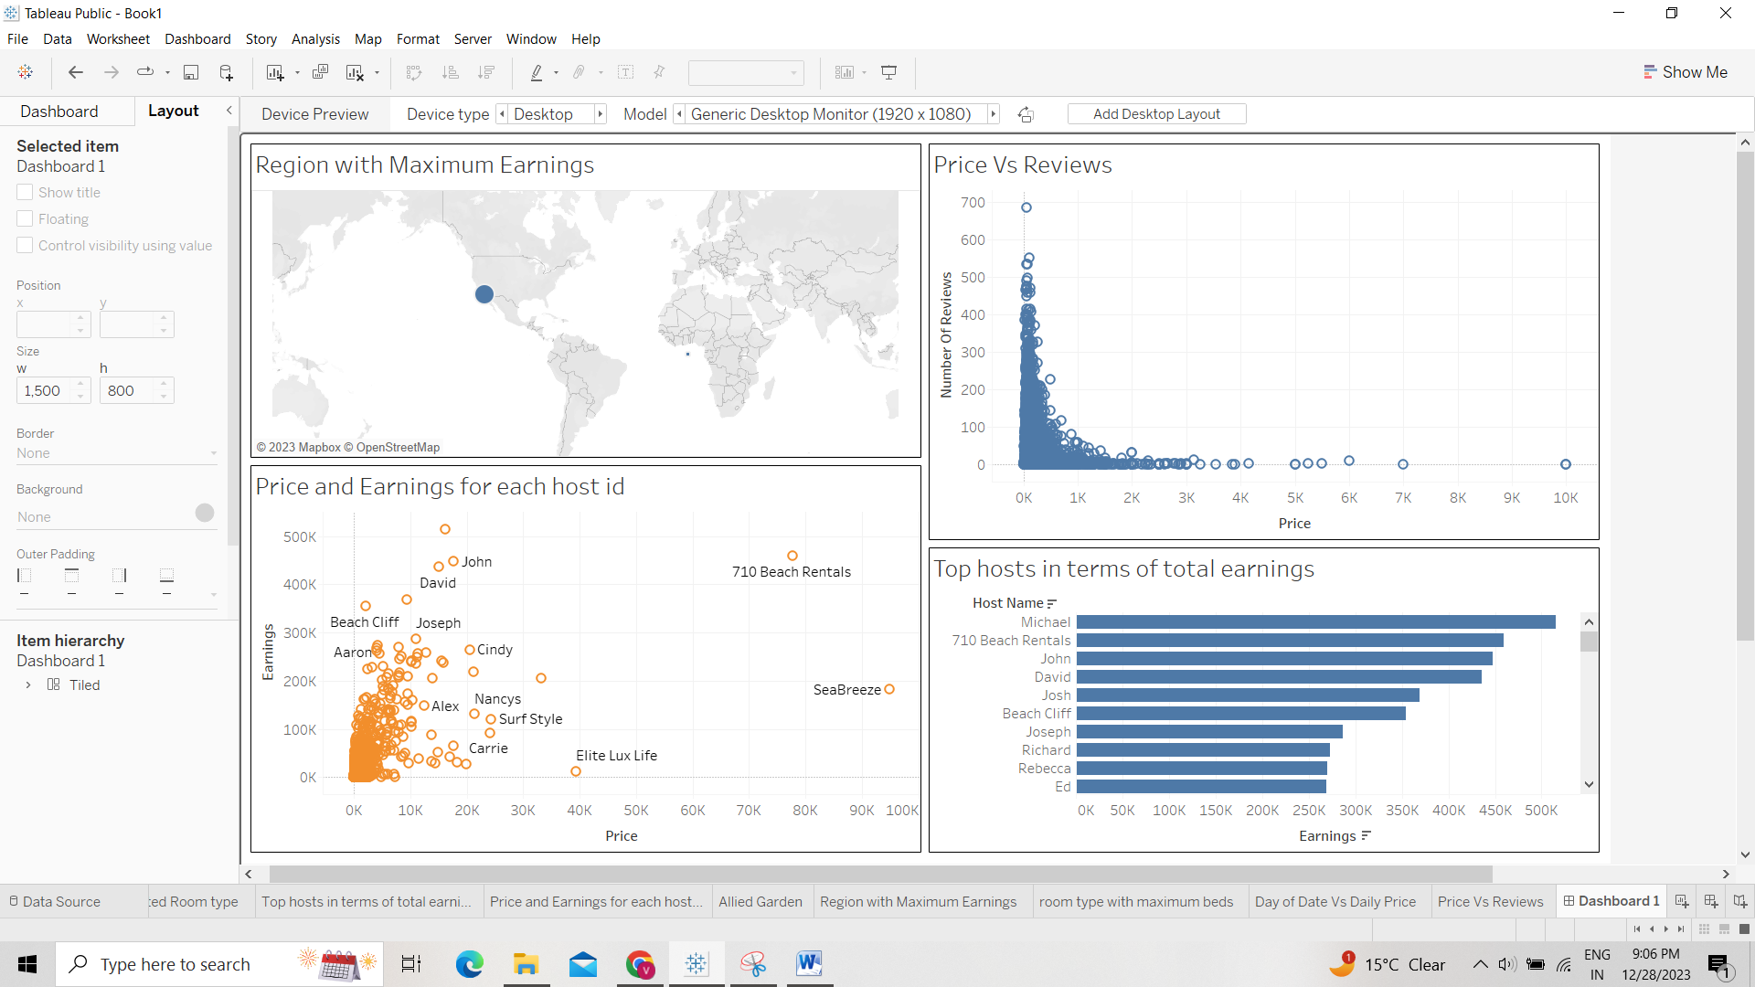

Story Board:

